**PROJECT ASSIGNMENT - 4**

**Keerthi Moparthi – 2868921**

**Havish Reddy Karra – 2873856**

**A Brief Description about Customized Health Api Project**  
The health and fitness industry has seen a surge in demand for personalized services in recent years. Consumers are looking for tailored solutions that fit their specific needs and lifestyles. With the help of AI-powered systems and API libraries, businesses are now able to offer highly customized products and services to meet these demands. The proposed health and fitness application is a prime example of how APIs can be used to develop a personalized solution that caters to the unique needs of each user.

The Spoonacular API library used in this application provides access to a vast database of recipes and nutrition information, which can be filtered based on the user's dietary preferences, allergies, and nutrition requirements. This data is then used to generate a customized meal plan and grocery list based on the user's calorie needs and dietary preferences. This allows users to have a clear understanding of what they need to eat to achieve their health goals, while also taking into account their dietary restrictions and preferences.

The Fitbit API library used in this application tracks the user's physical activity and generates personalized workout plans based on their fitness level and goals. By integrating Fitbit data into the application, users can receive tailored workout plans that take into account their current physical capabilities, allowing them to exercise safely and effectively. The use of this API also allows the application to track progress and provide personalized recommendations based on the user's performance, making it easier for them to achieve their health goals.

The Dialog Flow API library used in this application incorporates natural language processing to allow users to ask questions and receive personalized recommendations based on their health goals and preferences. This makes the application more user-friendly, as users can communicate with the application using natural language instead of having to navigate through complex menus and options. By providing a simple and intuitive interface, the application is more accessible to a wider range of users, including those who may not be tech-savvy or have limited experience with health and fitness apps.

The use of these API libraries makes it possible to create a highly personalized health and fitness application that can meet the unique needs of each user. By offering tailored solutions that take into account each user's health goals, dietary preferences, and physical capabilities, this application can help users achieve their desired results in a safe and effective manner. The use of APIs also makes the application more efficient, as it can automate many of the processes involved in generating customized plans, tracking progress, and providing recommendations.

**Context Diagram Health and Fitness**

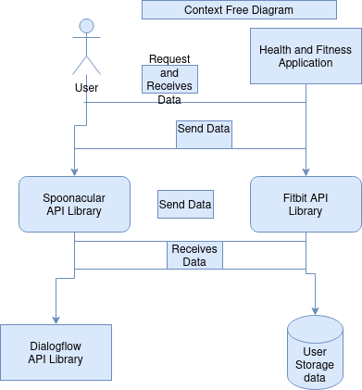

In this diagram, the user interacts with the Health and Fitness Application to receive personalized nutrition and workout plans. The application requests and receives data from the Spoonacular API library to generate customized nutrition plans and from the Fitbit API library to track the user's physical activity and generate personalized workout plans. The application also utilizes the Dialogflow API library to store and retrieve user data, including health goals, dietary preferences, and physical capabilities.

Here are user stories that align with this context diagram:

a) John, a 35-year-old office worker, wants to lose weight and build muscle. He downloads the Health and Fitness Application and inputs his current weight, height, and dietary restrictions. The application requests data from the Spoonacular API library to generate a customized nutrition plan and from the Fitbit API library to generate a personalized workout plan. The application stores John's data in the Dialogflow API library and uses it to provide personalized recommendations based on his health goals.

b) Sarah, a 28-year-old vegan, wants to improve her cardiovascular health. She downloads the Health and Fitness Application and inputs her dietary preferences, physical capabilities, and health goals. The application requests data from the Spoonacular API library to generate a customized nutrition plan and from the Fitbit API library to generate a personalized workout plan. The application stores Sarah's data in the Dialog Flow API library and uses it to provide personalized recommendations based on her health goals.

c) Tom, a 45-year-old with a knee injury, wants to stay active while avoiding further injury. He downloads the Health and Fitness Application and inputs his physical limitations and health goals. The application requests data from the Fitbit API library to generate a customized workout plan that includes low-impact exercises and stretches to help him stay active without causing further damage to his knee. The application stores Tom's data in the Dialog Flow API library and uses it to provide personalized recommendations based on his health goals.

**Client Server Architecture**

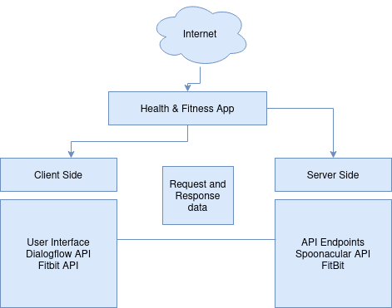

The above diagram illustrates that the Health and Fitness App is divided into two main components: the client-side and server-side.

The client-side consists of the user interface, which includes the Dialogflow API and the Fitbit API. The Dialogflow API allows users to ask questions and receive personalized recommendations based on their health goals and preferences using natural language processing. The Fitbit API is used to track the user's physical activity and generate personalized workout plans based on their fitness level and goals.

On the other hand, the server-side consists of the API endpoints that connect to the Spoonacular API and Fitbit API. The Spoonacular API is used to generate customized nutrition plans based on the user's dietary preferences and health goals. The Fitbit API is also used to track the user's physical activity and generate personalized workout plans based on their fitness level and goals.

Overall, the architecture of the Health and Fitness App is designed to provide a seamless and personalized experience for users, allowing them to easily access and utilize the application's features while also ensuring the secure and efficient transfer of data between the client and server.

**Client Server Architecture**

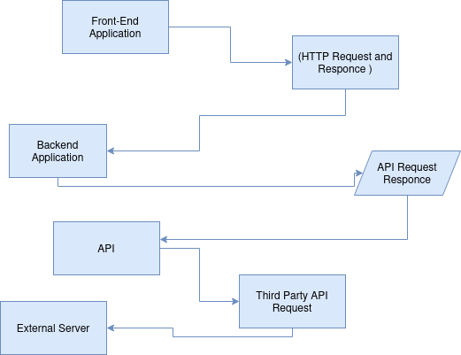

In this diagram, the front-end application interacts with the back-end application through HTTP requests and responses. The back-end application then makes requests to various APIs, such as the Spoonacular and Fitbit APIs, to generate personalized nutrition and workout plans. The back-end application also incorporates natural language processing through the Dialog Flow API to allow users to ask questions and receive personalized recommendations.

The external services module represents any additional services or systems that may be required to support the overall system, such as a database for storing user information or a payment gateway for handling subscription payments.

**Provide A Sequence Diagram**

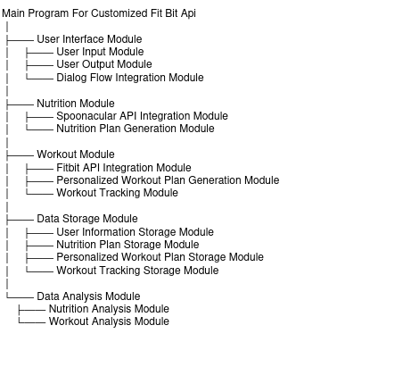

Each module in the system performs a specific function:

* Main Program: Controls the flow of the program and coordinates the different modules.
* User Interface Module: Handles user interaction with the system, including user input, output, and natural language processing through Dialog Flow integration.
* Nutrition Module: Generates customized nutrition plans using the Spoonacular API and stores them in the Nutrition Plan Storage Module.
* Workout Module: Generates personalized workout plans using the Fitbit API, tracks user workout progress, and stores both the workout plans and progress data in the Personalized Workout Plan Storage Module and Workout Tracking Storage Module, respectively.
* Data Storage Module: Stores user information, nutrition plans, personalized workout plans, and workout tracking data for future use and analysis.
* Data Analysis Module: Analyzes the nutrition and workout data stored in the Data Storage Module and provides insights and recommendations to the user.

**Here's a diagram to illustrate the structure chart:**

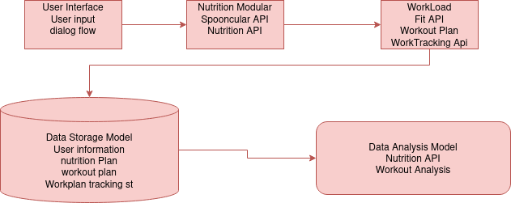

**Here is A Sequence Diagram:**

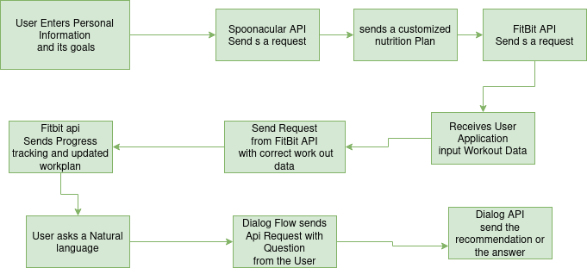

In this diagram, the user interacts with the application by entering personal information and health goals, as well as inputting workout data and asking natural language questions. The application uses the Spoonacular API to generate a customized nutrition plan based on the user's information and goals, and the Fitbit API to generate personalized workout plans and track progress. The Dialog Flow API is used to incorporate natural language processing and provide personalized recommendations or answers to user questions.